LAB 2: Dynamic Systems Modeling in Simulink

Course Number | MENG 3020
Course Title | System Modeling & Simulation
Semester/Year | Semester 3

Lab/Tutorial Report No. | Lab 2
Report Title | Dynamic Systems Modeling in Simulink
Section No. | 0NA
Group No. | N/A
Submission Date | October 5th, 2025
Due Date | October 5th, 2025

Student Name | Signature* | Total Mark
Michaël McCorkell |  | / 50

* By signing above, you attest that you have contributed to this submission and confirm that all work you have contributed to this submission is your work. Any suspicion of copying or plagiarism in this work will result in an investigation of Academic Misconduct and may result in a ZERO on the work or possibly more severe penalties.
https://academic-regulations.humber.ca/2021-2022/17.0-ACADEMIC-MISCONDUCT

LAB 2 Grading Sheet

Student First Name:  Michaël | Student Last Name:  McCorkell
Part A.1: Nonlinear Model of Vehicle Suspension System |  | /15
Part A.2: Linear Model of Vehicle Suspension System |  | /8
Part A.3: Active Suspension Control System |  | /7
Post Lab Assignment |  | /15
General Formatting: Clarity, Writing style, Grammar, Spelling, Layout of the report |  | /5
Total Mark |  | /50

LAB 2: Dynamic Systems Modeling in Simulink

OBJECTIVES
- To learn how to simulate non-linear and linear differential equation model in Simulink.
- To compute the time response of a system to any arbitrary input signal.
- To explore modeling of equations of motion in Simulink.

INTRODUCTION
Simulink provides a graphical user interface that uses various types of elements called blocks to create a simulation of a dynamic system, which is a system that can be modeled with differential equations whose independent variable is time. For example, one block type is a multiplier, another performs a sum, and another is an integrator. Its graphical interface enables you to position the blocks, resize them, label them, specify block parameters, and interconnect the blocks to describe complicated system for simulation.
Type simulink in the MATLAB Command window to start Simulink. The Simulink window opens. To create a new model, click on the Blank Model. A new untiled window opens for you to create the model. Then open the Library Browser by selecting it in the drop-down menu under the View menu. To select a block from the Library Broser, click on the appropriate library category and a list of blocks within that category then appears. Click on the block name or icon, hold the mouse button down, drag the block to the new model window, and release the button. You can access help for that block by right-clicking on its name or icon and selecting Help from the drop-down menu.
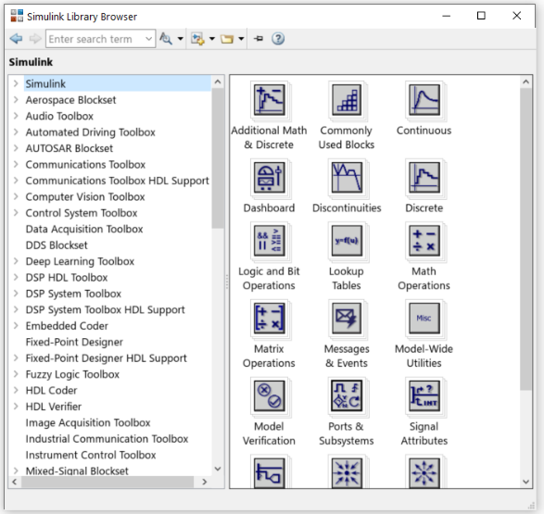
Refer to MENG-2000 Tutorial 2: Simulink Interactive Tutorial document for more details on start Simulink.
Figure 1: Simulink Library Browser
Simulink model files have the default extension .slx as of Release 2019a. The .slx format is a new compressed format that provides smaller file sizes. The .mdl format is still available as a save option.
You can use the File menu in the model window to Open, Close, and Save model files. To print the block diagram of the model, select Print on the File menu. Use the Edit menu to copy and paste blocks. You can also use the mouse for these operations. For example, to delete a block, click on it, and press the Delete key.

Simulink Model of Vehicle Suspension System
The single-mass quarter-car model of a vehicle suspension is shown below. In this simplified model, the masses of the wheel, tire, and axle are neglected, and the mass $m$ represents one-fourth of the vehicle mass. The spring constant $k$ models the series combination of the elasticity of the tire and the suspension spring. The damping coefficient $b$ models the shock absorber. The motion of the mass $m$ is produced by the motion $y\left(t\right)$ of the base, in this case, the road surface. The road surface displacement $y(t)$ can be derived from the road surface profile and the car’s speed. The equilibrium position of mass $m$ when $y\text{=}0$ is $x\text{=}0$.
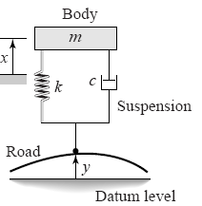
$$b$$

Figure 2: A quarter-car model with a single mass

Linear Model & Transfer Function
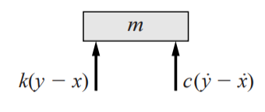
Assume that the spring and damper have linear models, which means the spring force $f_{s}$ is proportional to the relative displacement and the damping force $f_{d}$ is proportional to the relative velocity.
$$b\left(\overset{˙}{y}\text{-}\overset{˙}{x}\right)$$
$f_{s}\text{=}k(y\text{-}x)$ and $f_{d}\text{=}b(\overset{˙}{y}\text{-}\overset{˙}{x})$
From the free body diagram, we obtain the equation of motion:
$$f_{s}\text{+}f_{d}\text{=}m\overset{¨}{x} → k\left(y\text{-}x\right)\text{+}b\left(\overset{˙}{y}\text{-}\overset{˙}{x}\right)\text{=}m\overset{¨}{x}$$
The transfer function model is found by applying the Laplace transform to the equation, with the initial conditions set to zero:
$$\frac{Y\left(s\right)}{X\left(s\right)}\text{=}\frac{bs\text{+}k}{ms^{2}\text{+}bs\text{+}k}$$

Nonlinear Model
In nonlinear spring and damper, there is no linear relationship with displacement and the velocity.
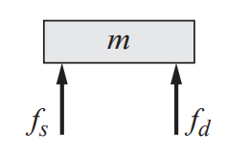
The equation of motion is in general form:
$$f_{s}\text{+}f_{d}\text{=}m\overset{¨}{x}$$
where, the spring force $f_{s}$ and the damping force $f_{d}$ are determined based on the nonlinear characteristics of the components.
The goal is to derive the equation of motion of mass $m$ with $y(t)$ as the input and obtain the Simulink model of the system.
A.1 Nonlinear Model of Vehicle Suspension System
In this part, assume that the spring and damper elements have the nonlinear models as shown below,
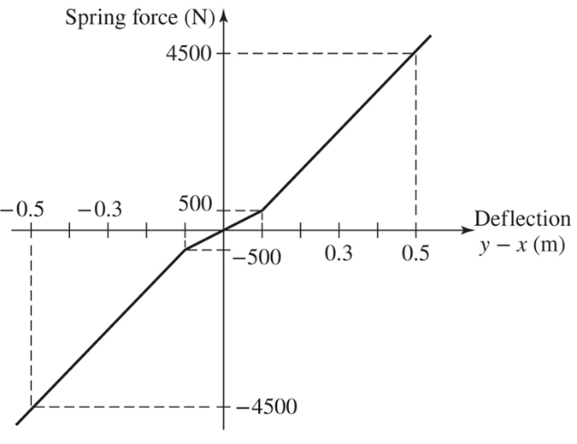
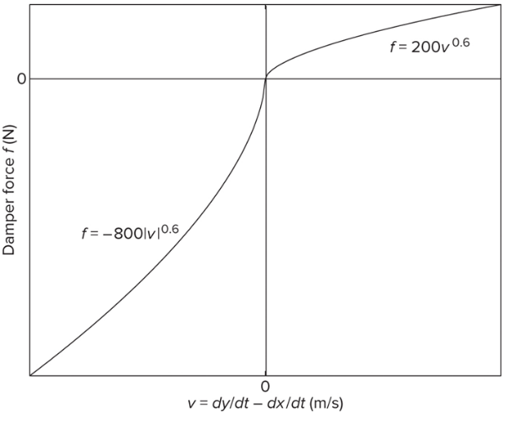

(a) (b)
Figure 3: (a) Hardening Spring model, (b) Degressive Damper model

These models represent a hardening spring and a degressive damper. In addition, the damper model is asymmetric. It represents a damper whose damping during rebound is higher than during jounce (to minimize the force transmitted to the passenger compartment when the vehicle strikes a bump).
The bump is represented by the trapezoidal function $y(t)$ shown below. This function corresponds approximately to a vehicle traveling at $30 mi\text{/}h$ over a $0.2 m$ high road surface elevation $48 m$ long.
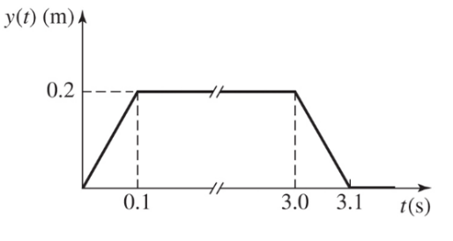
Figure 4: Road bump profile


The system model from Newton’s law is:

$f_{s}\text{+}f_{d}\text{=}m\overset{¨}{x}$
where,
$m$ is one-fourth of the vehicle mass ($m\text{=}400 kg$),
$f_{s}$ is the nonlinear spring function shown in Figure 3a,
$f_{d}$ is the is the nonlinear damper function shown in Figure 3b,
$x$ is the displacement of the car mass,
$y$ is the displacement of road bump profile shown in Figure 4,
The corresponding simulation diagram is shown as:
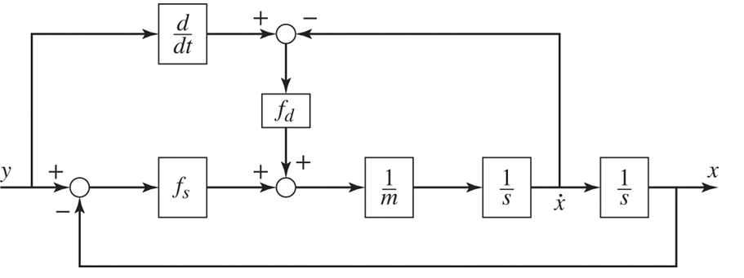
Figure 5: Block diagram model

This diagram shows we need to compute $\overset{˙}{y}$. Because Simulink uses numerical and not analytical methods, it computes derivatives only approximately, using the Derivative block. We must keep this in mind when using rapidly changing or discontinuous inputs.
- Start Simulink and open a new window.
- Create the following Simulink model to solve for and plot $x(t)$
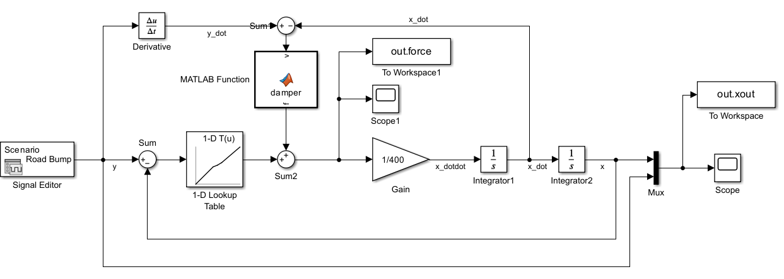
Figure 6: Simulink block diagram model

- Open the Simulink Library Browser window and select the following blocks:
- The Gain block from the Simulink/Math Operations category.
- Change the Gain value to 1/400.
- The Integrator blocks from the Simulink/Continuous category.
- The Derivative block from the Continuous category.
- The Mux block from the Signal Routing category.
- The Sum blocks from the Math Operations category.
- Set the signs as |+-, ++| and +-. Rotate the blocks if required.
- Two Scope block from the Simulink/Sink category.
- Two To Workspace blocks from the Simulink/Sink category.
- Change the output Variable name of To Workspace block to xout and specify the Save Format as Array.
- Change the output Variable name of To Workspace1 block to force and specify the Save Format as Array.
- The MATLAB Function block from User-Defined Functions category.
- Open the MATLAB Function block and program the block as below:
function f = damper(v)

if v <= 0
f = -800*(abs(v)).^(0.6);
else
f = 200*v.^(0.6);
end

- The 1-D Lookup Table block from Lookup Tables category.
- Enter [-4500 -500 0 500 4500] for Table data values and [-0.5 -0.1 0 0.1 0.5] for Breakpoints 1 values. Use default settings for the remaining parameters.

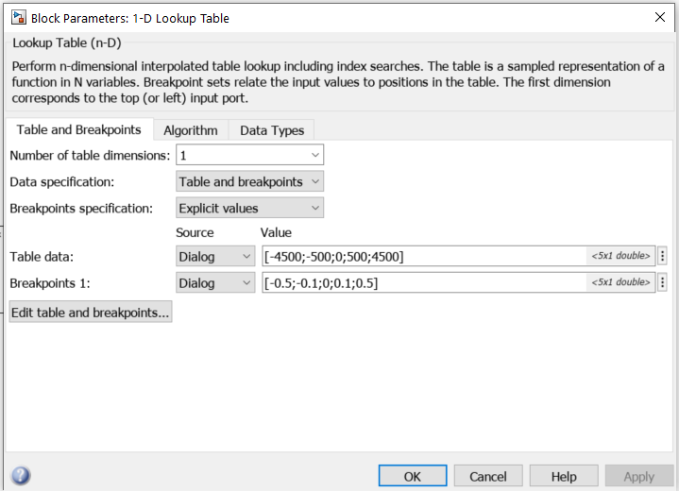

- The Signal Editor block from Source category.
- Open the Signal Editor block to define the input function profile based on the Figure 6 as below:
- Click on icon to open the Signal Editor window.
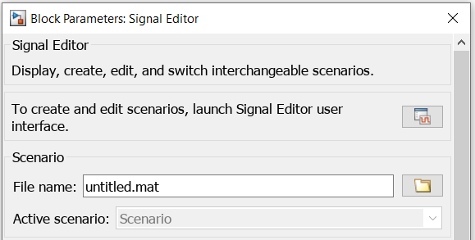

- Click on the small drop-down icon beside the Scenario to see the signal present in it, which is named Signal 1 by default.
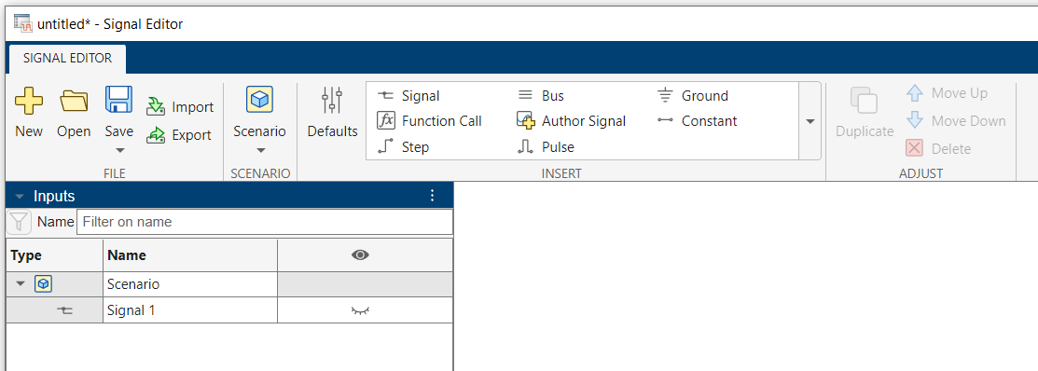

- Double-click on the icon in the right side of the Signal 1 to reveal what is in this signal.
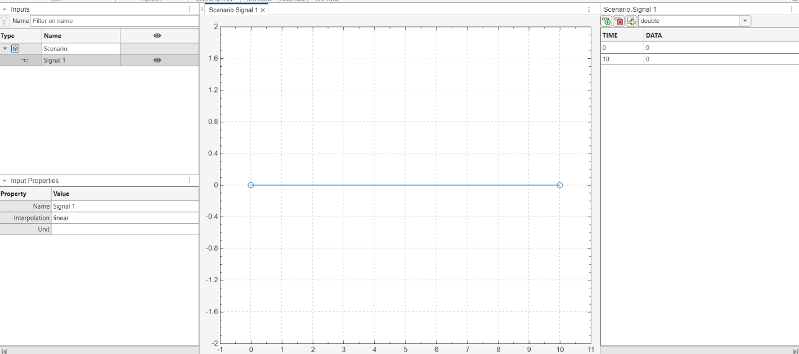
- The signal is blank at the first time. You can add the data for your signal profile by editing the data table in the right side.
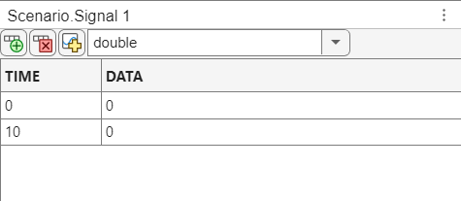
- Click on icon to add more rows to the data table.
- Enter the Time values as [0 0.1 3 3.1 10] and Data values as [0 0.2 0.2 0 0] based on road bump profile from Figure 6.
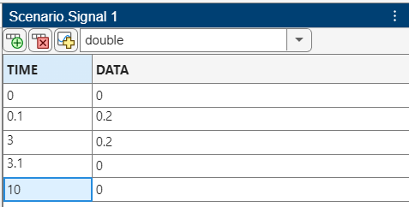

- The road bump profile will be created. Click on the signal name and rename the signal as Road_Bump.

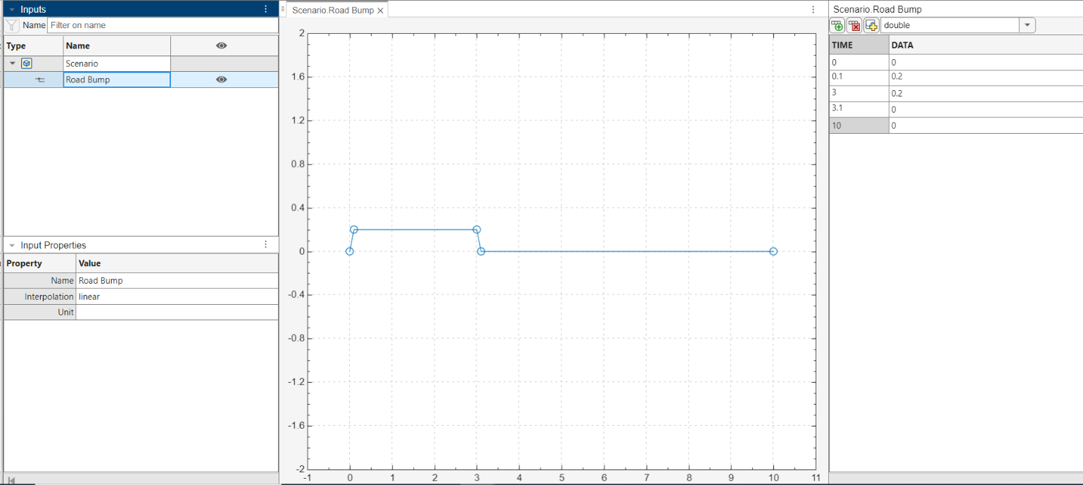

- Save the signal file as Input.mat in the same folder you will save the Simulink file.
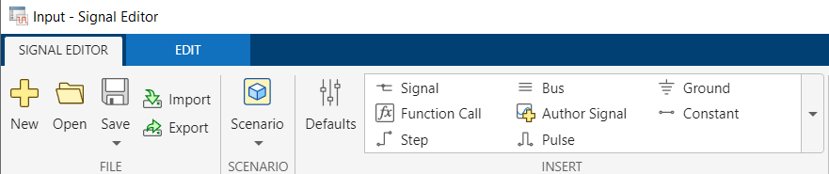

- The signal file name will be appeared in the Block Parameters Dialogue window.
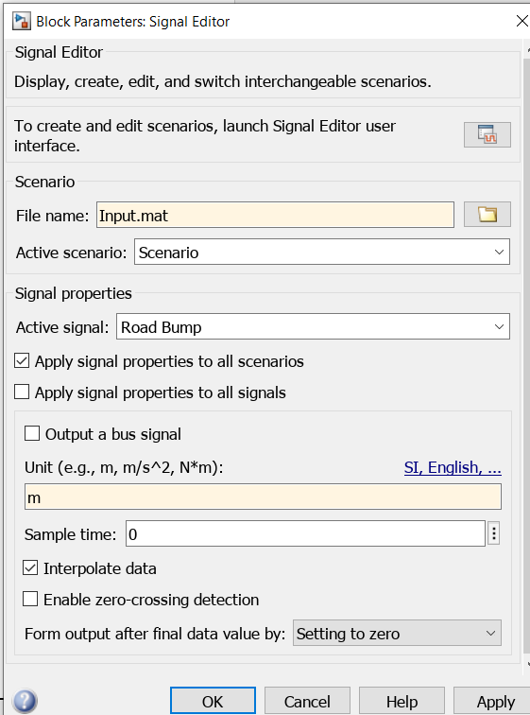

- Set the signal data unit as m (meter) in the Unit box.
- Check marks the Interpolate data box.
- Click OK to close the dialogue window.

- Save the Simulink model file as Lab2_PartA1.slx.
- Run the simulation for 10 seconds. Open the Scope block to check the results. Use Cursor Measurement to determine and record the required values in Table 1.

Table 1
Maximum Overshoot (m) | Maximum Undershoot (m)
0.0580 | 0.1647

- Plot the road bump profile and the displacement of body in MATLAB using the following code:
plot(out.tout,out.xout), grid on
xlabel('time (sec)'), ylabel('x & y (m)')
title('Displacement of Body & Road Profile - (Nonlinear Model)')
- Provide your Simulink block diagram and the MATLAB plot below:
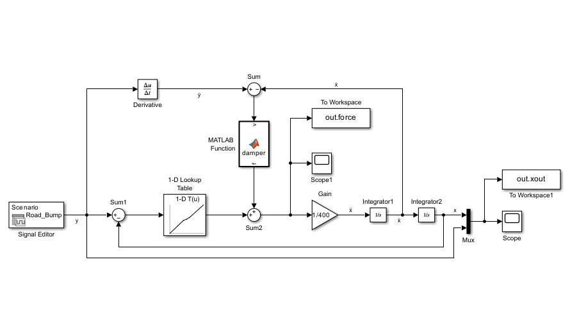

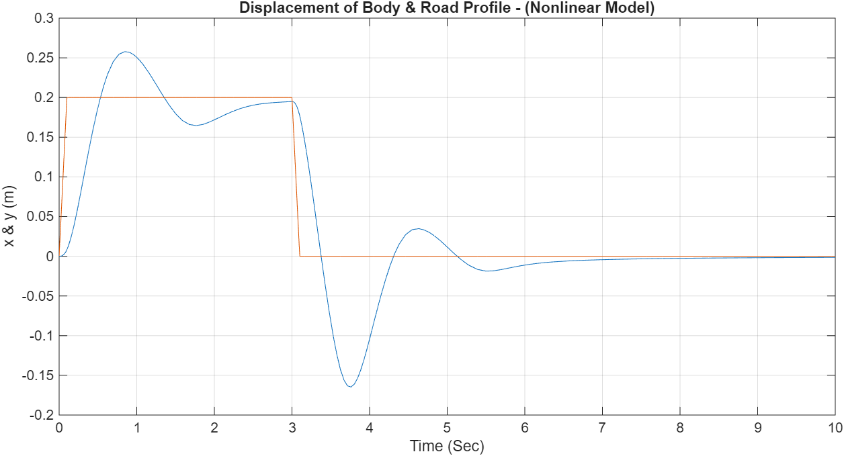

- Open the Scope 1 block to check the results, which displays the overall spring and damper forces transmitted to the chassis.
- Plot the force graph in MATLAB using the following code:
plot(out.tout,out.force), grid on
xlabel('time (sec)'), ylabel('Force (N)')
title('Total transmitted force – (Nonlinear Model)')
- Provide the force plot below:
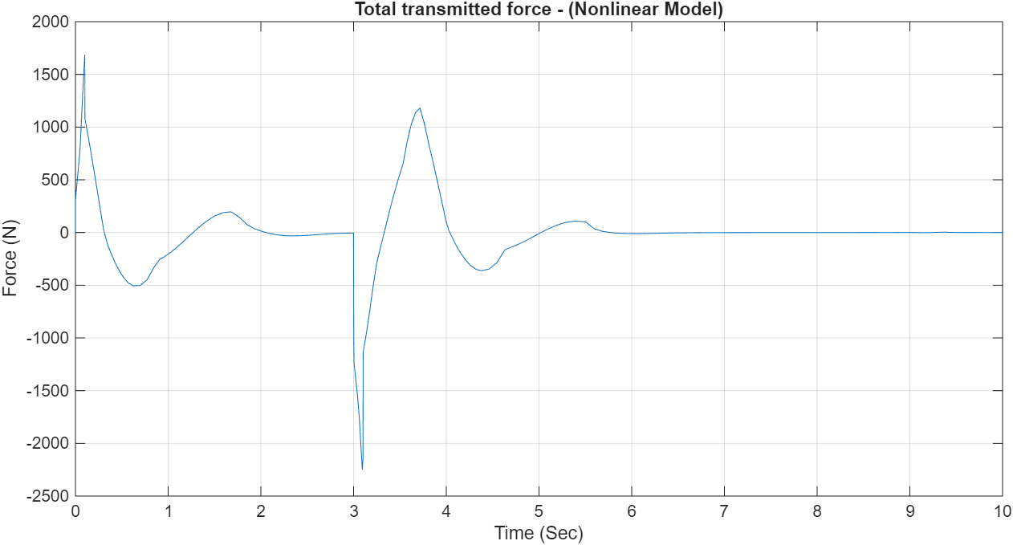

A.2 Linear Model of Vehicle Suspension System
In this part, the goal is to derive a linear model for the spring and damper elements over a range of operation, where the displacement range is $\text{-}0.1≤y\text{-}x≤0.1 m$ and the velocity range is $\text{-}0.1≤\overset{˙}{y}\text{-}\overset{˙}{x}≤0.1 m\text{/}s$.
The linearized equation of motion is:
$$f_{s}\text{+}f_{d}\text{=}m\overset{¨}{x} → k\left(y\text{-}x\right)\text{+}b\left(\overset{˙}{y}\text{-}\overset{˙}{x}\right)\text{=}m\overset{¨}{x}$$
- Estimate the spring constant $k$ and damping coefficient $b$ and obtain a linear approximation for each element. Show your work below.
T = 3sec – 0.85sec → 2.15 sec
wd = 2pi/T → ≈ 3 rad/s
p1 = 0.25m p2 = 0.2m
log decrement =ln(p1/p2) → ln(0.25/0.2) ≈ 0.22
dampening ration = 0.22/root(4pi^2+0.22^2) ≈ 0.035
wn = wd/ root(1-dr^2) → 3/root(1-0.035^2) → ≈ 3.002 rad/s

k=m(wn)^2 → 400*(3.002)^2 ≈ 3604.415 N/m
b = 2m(dr)(wn) → 2*400*0.035*3.002 → 84.056 Ns/m

Provide the linear model of each element in Table 2.
Table 2
Linear Spring Model | Linear Damper Model
k(y-x) → 3604.415(y-x) | b(ẏ-ẋ) → 84.056(ẏ-ẋ)

- Modify the Simulink model diagram by replacing the spring constant block and editing damping coefficient block.
- Save the Simulink model file as Lab2_PartA2.slx.
- Run the simulation for 10 seconds. Open the Scope block to check the results. Compare them with the obtained results of nonlinear model in Part A1. Is the linearized model acceptable in the given operation range?
Yes, the linearized model is acceptable. Since the linearized response closely matches the nonlinear model’s steady or near-steady behavior (both showing little or no oscillation), it means the linear approximation accurately represents the system dynamics within that operating range.

- Plot the road bump profile and the displacement of body in MATLAB using the following code:
plot(out.tout,out.xout), grid on
xlabel('time (sec)'), ylabel('x & y (m)')
title('Displacement of Body & Road Profile – (Linear Model)')
- Provide your Simulink block diagram and the MATLAB plot below:
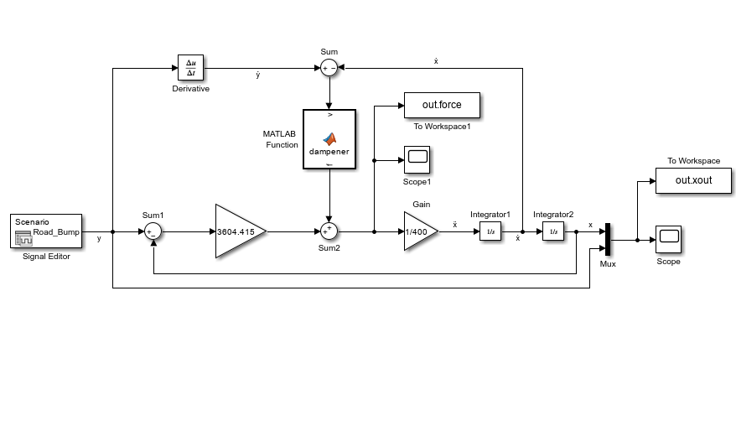

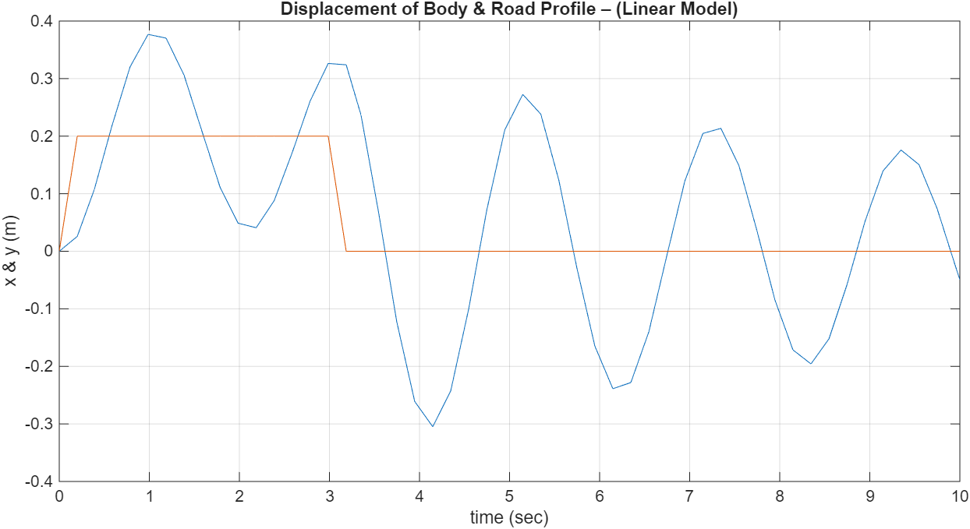

A.3 Active Suspension Control System
Oscillation of the body mass can be decreased by adding an Active Suspension controller to the system. An active suspension supplements the car’s passive suspension system that consists of springs and shock absorbers. An electric motor or a hydraulic servomotor is mounted either in parallel or in series with the spring and shock absorber. The actuator is under computer control so that its force can be adjusted to apply more force in response to varying conditions, for example to maintain traction during turns or to compensate for increased passenger and cargo weight.
Figure 7 illustrates the principle for a single-mass, quarter-car suspension model. The servomotor is shown in parallel with the spring and damper. Assume that the servomotor force is proportional to the chassis displacement $x$ and the chassis velocity $\overset{˙}{x}$, so that
$$f\text{=}\text{-}K_{p}x\text{-}K_{D}\overset{˙}{x}$$
where $K_{p}$ and $K_{D}$ are constants, whose value must be determined by the designer and programmed into the computer.
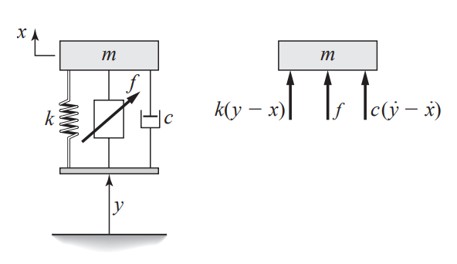
$$b$$
$$b(\overset{˙}{y}\text{-}\overset{˙}{x})$$

Figure 7: A quarter-car model with an active suspension system
Assuming the linearized model, the equation of motion is:
$$f_{s}\text{+}f_{d}\text{+}f\text{=}m\overset{¨}{x} → k\left(y\text{-}x\right)\text{+}b\left(\overset{˙}{y}\text{-}\overset{˙}{x}\right)\text{+}(\text{-}K_{p}x\text{-}K_{D}\overset{˙}{x})\text{=}m\overset{¨}{x}$$
Rearranging the equation:
$$m\overset{¨}{x}\text{+}\left(b\text{+}K_{D}\right)\overset{˙}{x}\text{+}\left(k\text{+}K_{p}\right)x\text{=}b\overset{˙}{y}\text{+}ky$$
We immediately see that the gain $K_{p}$ acts like artificial stiffness, and the gain $K_{D}$ like an artificial damper. Thus, we can change the effectiveness stiffness and damping by properly selecting the gains.
The corresponding simulation diagram is shown as:
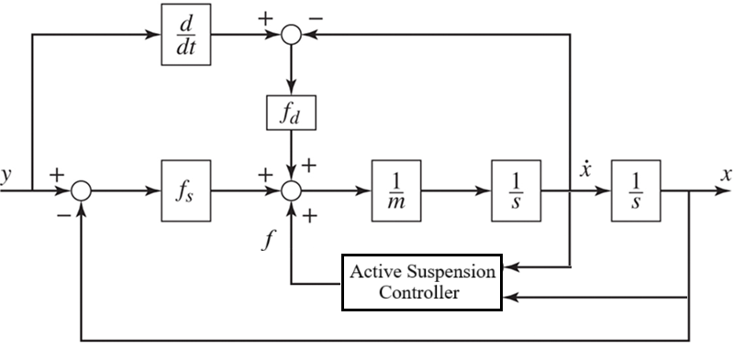
NOTE: Design of the controller gains is out of scope of this course. It is covered in the Control Systems course.

- Select the controller gains as $K_{p}\text{=}10$ and $K_{D}\text{=}2500$.
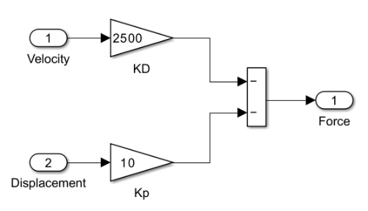
- Create the controller block using Subsystem block and including the required blocks as shown below
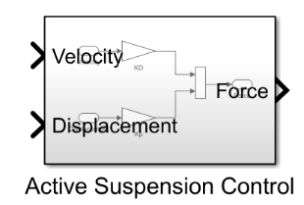

- Modify the Simulink model diagram in Part A1 and Part A2 by adding the designed controller block. Provide the Simulink model diagrams below:
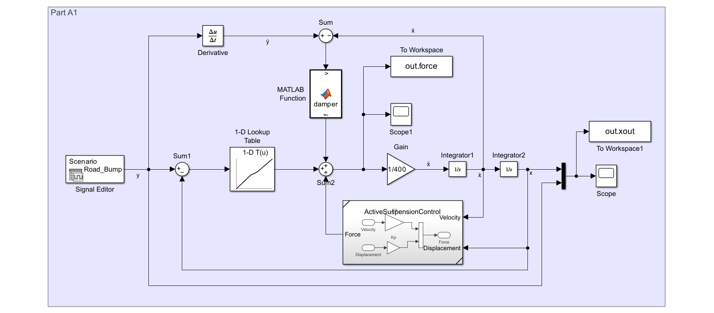

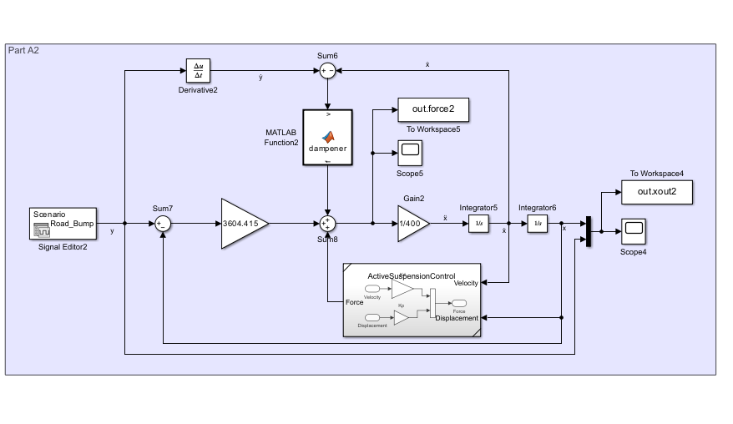

- Run the simulation for 10 seconds. Open the Scope block to check the results. Does the controller enhance the oscillation of the body mass?
No the controller does not enhance oscillations of the body mass. In the second plot, the yellow response shows a smooth rise and a well-damped return after the step input (blue), indicating that oscillations are reduced rather than amplified. The system settles quickly without sustained or increasing oscillations, meaning the controller effectively improves stability and damping.

- Plot the road bump profile and the displacement of body in MATLAB using the following code:
plot(out.tout,out.xout), grid on
xlabel('time (sec)'), ylabel('x & y (m)')
title('Displacement of Body & Road Profile with Controller')
- Provide the MATLAB plot below:
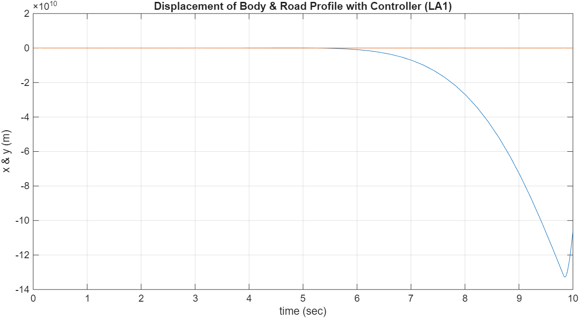

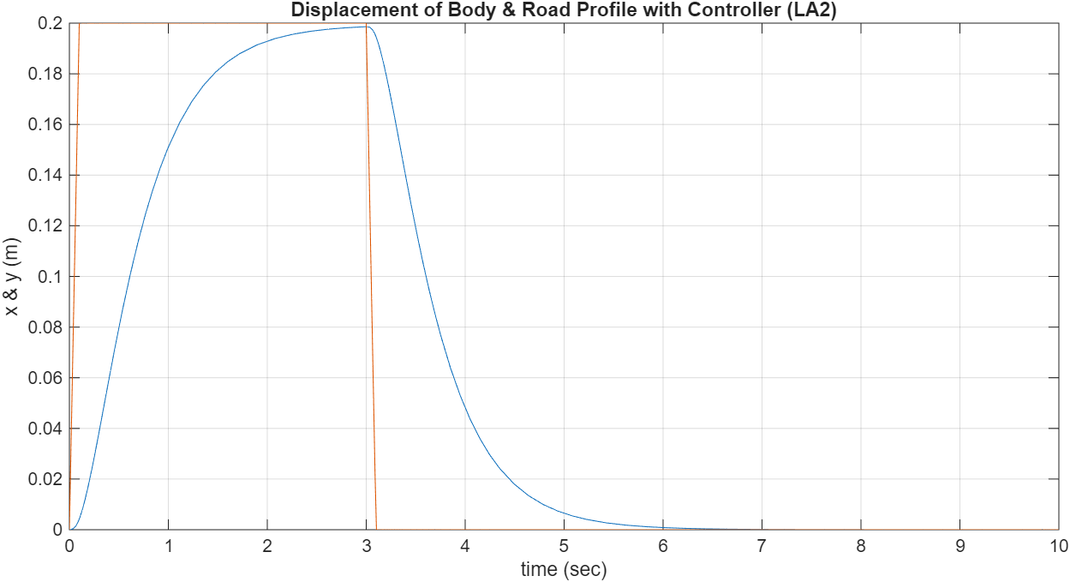

Post Lab Assignment
- Develop a Simulink model to solve the following differential equation model:
$$\overset{˙}{y}\left(t\right)\text{=}\text{-}10y\left(t\right)\text{+}f\left(t\right), y\left(0\right)\text{=}1$$
where $f\left(t\right)\text{=}2sin4t,$ for $0≤t≤3.$
Run the simulation for 3 seconds and plot the results in MATLAB. Provide the Simulink model, required code to plot the graph and the results. Add the required titles and labels to the graph.
Hint: You can use the following model to develop the simulation.
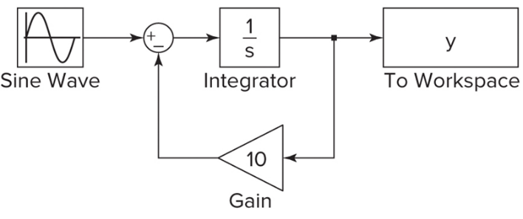
out.yout
---------------------------------------------------------------------------------------------------------------------------------
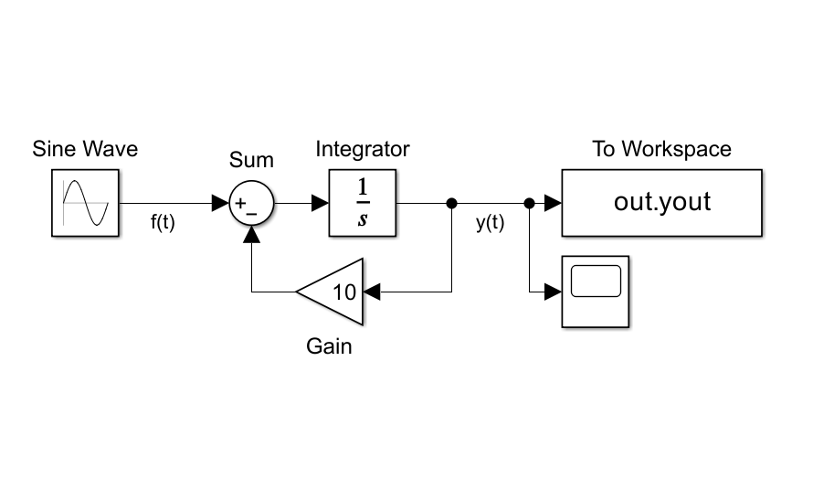
figure;
plot(out.yout), grid on
xlabel('Time (sec)'), ylabel('Function')
title('Post Lab Question 1')

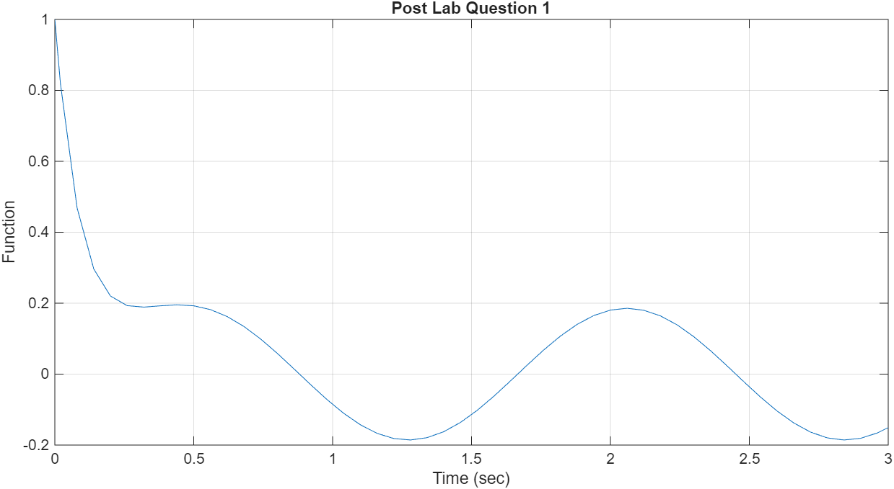

- Consider the Simulink suspension model developed in Part A.1 Figure 6. Modify the simulation using the following spring and damper relation and the given road bump profile as the input.
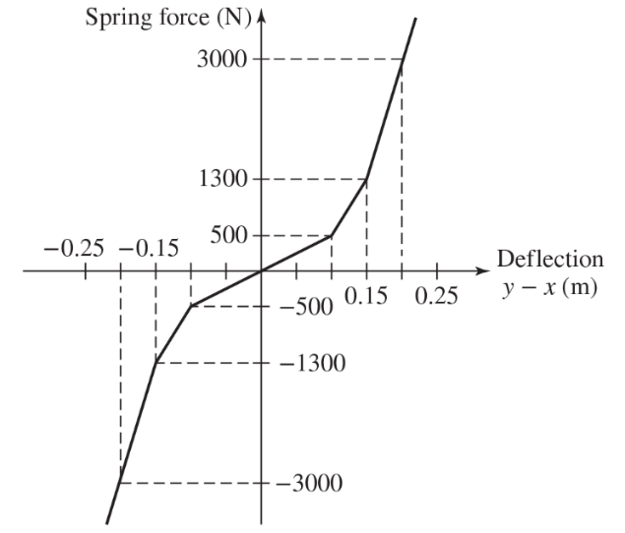
$f_{d}=\left\{\begin{aligned}−500{\left|v\right|}^{1.2} v≤0 \\ 50v^{1.2} v\text{>}0\end{aligned}\right.$

Damper Model
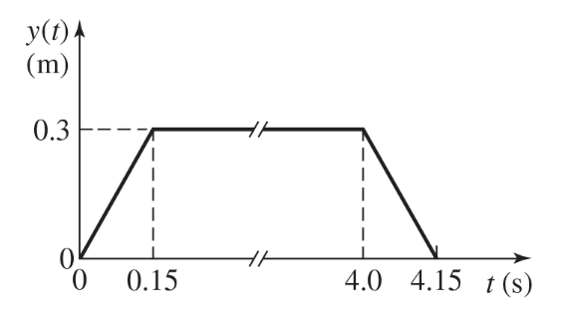

Spring Model Road Bump Profile
Run the simulation for 15 seconds and plot the responses in MATLAB. Provide the Simulink model, the required code to plot the graphs and the displacement graph and the force graph. Add the required titles and labels to the graphs.
Evaluate the overshoot and undershoot of the mass displacement. Provide the results.
Dampener function | function f = damper(v)  if v<= 0  f = -500*(abs(v)).^(1.2);  else  f = 50*v.^(1.2);  end
Spring force | [-3000;-1300;-500;0;500;1300;3000]  [-0.2;-0.15;-0.1;0;0.1;0.15;0.2]
Code | plot(out.tout,out.xout), grid on  xlabel('Time (Sec)'), ylabel('x & y (m)')  title('Displacement of Body & Road Profile')  figure;  plot(out.tout,out.force), grid on  xlabel('Time (Sec)'), ylabel('Force (N)')  title('Total transmitted force')
Overshoot (m): 0.2246 m | Undershoot (m): 0.1814 m

